Lab 11 : Blind SQL injection with conditional responses

**Overview**  
This lab required leveraging true/false conditions in SQLi to infer data.

**Key Concepts Covered**

* Boolean-based blind SQLi
* Detecting application behavior differences

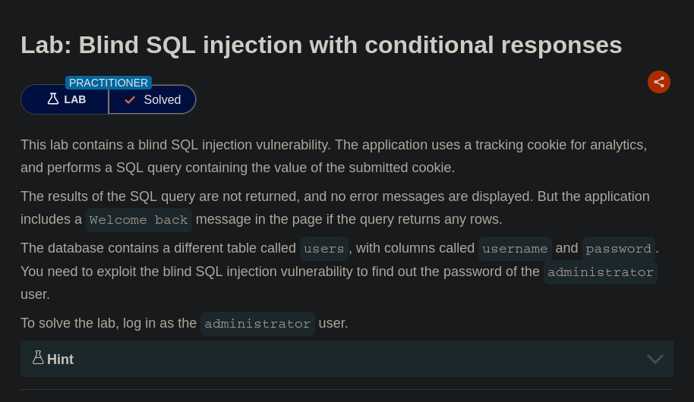

**Completion**

* Difficulty: Hard
* Status: Completed